s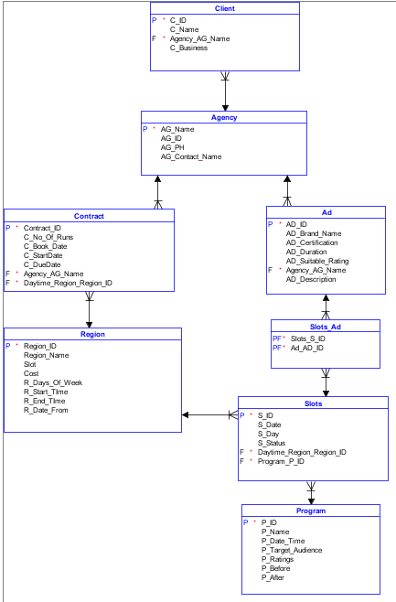

To begin with, we have 3 non-dependent tables (Agency, Program & Regions) and 4 dependent table (Ads, Clients, Contract & Slots) with a weak entity (Runs).

The Agency table is created to hold the details of the agency. The Program table holds the information of each program. The Regions table stores information about each region including the cost price to buy an ad slot in it and the amount of available slots in each region. The Slots table stores information about each slot, like it’s scheduled date & time, the day it’s due to be played and it’s status, i.e. if it’s free for more ads, or if all its slots are allocated.

The Ads table holds all the information about an ad and is linked to the Agency table as an agency supplies the ad from a Client. Brand Name in the ads table is the brand name for which the client(representative) is buying an ad slot for. It’s one to many from Agency to Ads as an agency can supply from different clients, many ads. The Client table holds the information about a client (their id and name). The client name is the representative for the company. Each client is linked to agency, and an agency can have many clients.

So, the way in which this system works is that a client has to have a agency to buy an ad slot. A contract is then made for the client which has all the details such as number of runs the ad will make. The ad is assigned to a free slot in the schedule of a specific region, and which region it is in is dependent on the suitability rating it has.